Integrating research
and outreach education
from UMass Amherst

UMass Extension Fruit Team
Fact Sheet #

IPM Fact Sheet Series

What is Permaculture?

Permaculture is an ethics-based method of land management grounded in environmental reciprocity, sustainability, and on maintaining a synergistic (i.e. collaborative, prolonged benefit-based) relationship with the local ecosystem. The term “permaculture” was coined by academics Bill Mollison and David Holmgren in 1978, however, the principles and techniques pre-date colonization; Mollison attributes a great deal of his knowledge to indigenous cultures, most notably the Aboriginal people of Tasmania. The desired outcome is to produce food in abundance with altruistic intentions while making intensive use of the site, concentrating on energy efficient and eco-friendly practices. For instance, by incorporating wild food foraging and non-food crops, as well as harnessing ecological contributions of livestock and resident wild animals, permaculture imitates the natural ecosystem to ensure an effective, resilient food cultivation system, and foster an integrated understanding of one’s impact and role in their environment, both in the garden and in the broader community.

The Three Pillars of Sustainability
Sustainability is the degree to which a process or enterprise can be maintained while avoiding the long-term depletion of vital resources. Economic factors, ecological factors, and social equity.

Equity
Economy
Ecology

Sustainable

Principles:
Permaculture requires a conscientious regard for the environment, and an understanding that humans are fundamentally part of it, rather than living adjacent to it. This insight drives a focus on building and bolstering harmonious relationships with the land, other animal species, and the community, through regenerative practices, symbiosis (a joint beneficial relationship between organisms), and mutual aid (giving assistance through non-institutionalized means). Biomimicry (emulating nature and its processes) and relies on collective action to achieve a hardy and adaptable framework, supported by strategically channeling the inherent properties and behaviors of both biotic and abiotic factors present, rather than fighting against them; considering how a problem can be redirected and turned around into a beneficial situation. Ideally, an established permaculture garden is largely self-managed. The ethos of permaculture encourages the development of maverick skills and strategies dissenting from typical solutions for the sake of self-reliance.

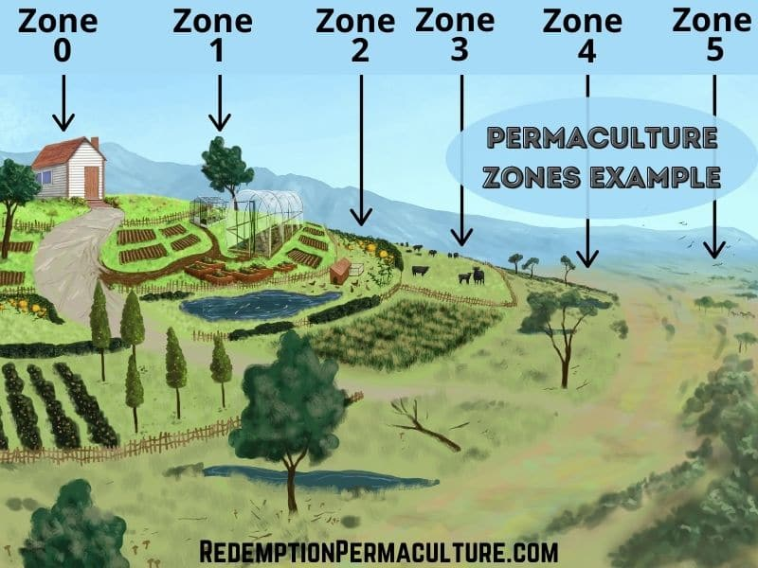
Techniques:

This image is a basic rendition of how a site is organized into zones. The zones are not necessarily sequential, or there could be multiples of a zone (i.e. a second zone 2 by the pond in zone 4). The border between zones 2 and 3 is an example of using marginal spaces: the fence hosts a climbing plant that offers shade, privacy between livestock, fodder, and mulch when the foliage is pruned. Zones don’t have to be permanent; zones 3 and 4 can switch year to year for rotational planting and grazing.

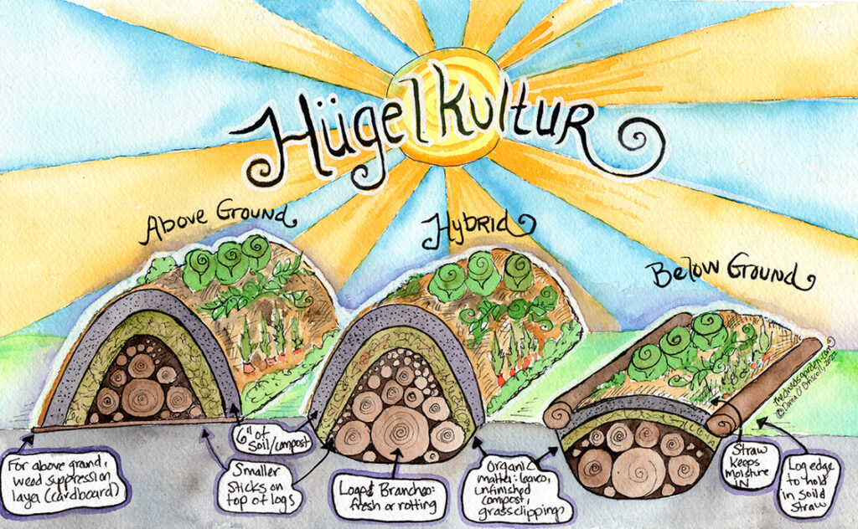
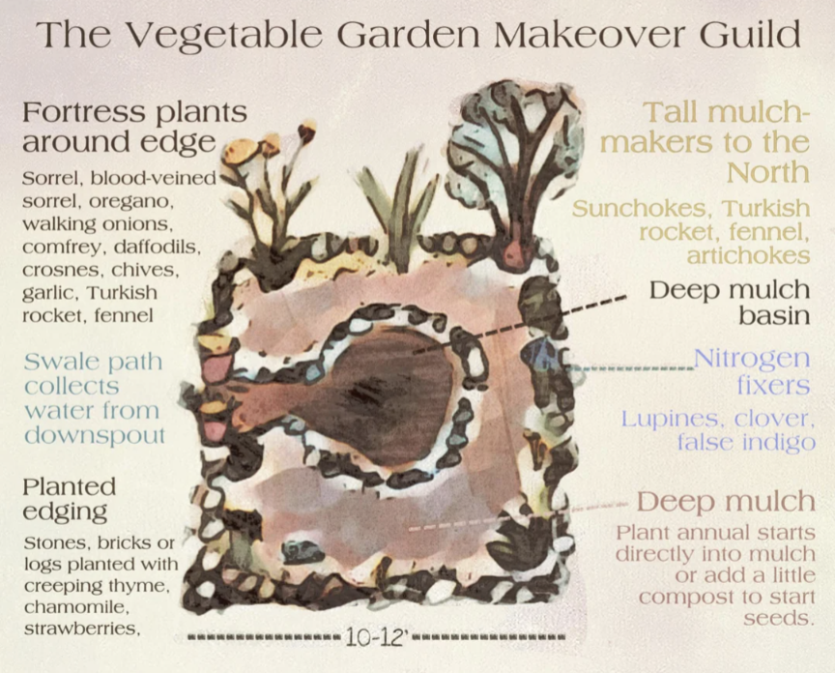
In order to satisfy the aforementioned principles and yield the benefits of permaculture, all components must be considered and approached with creativity, simplicity, and sustainability in mind. The design process includes creating a base map along with a sector map (analyzing the movement of external factors, i.e. the direction of the sun and wind and their seasonal variance), and organizing the site into five zones, zone 1 being the most frequently visited and zone 5 denoting wilderness that is not altered and rarely visited (the home is zone 0). In permaculture, multifunctionality is key; keyhole gardens accumulate solar energy, increase growing space, and accommodate plant guilds. Installing a raised crop bed, also known as Hügelkultur, and treating fences like trellises creates vertical growing space. Incorporating agroforestry, with trees and shrubs that prevent erosion, can provide site-specific benefits such as a shady spot or windbreak, or even develop microclimates to diversify growing conditions and increase the resilience of the site. Maintaining respect for the land is achieved through regenerative practices, such as growing green manure crops between harvesting to return nutrients to the soil, ensuring better production the following year. Utilizing the landscape’s natural patterns to sequester wind, rain, and solar energy results in greater production and reduced financial and labor input.

Hügelkultur is a style of raised garden bed, introduced by Austrian permaculturist Sepp Holzer, that starts with a core of wood and plant matter that would have otherwise been discarded as waste. It is then topped with soil and compost. Hügels hold moisture well, and become more fertile over time. For increased surface area and planting space, they can be piled high above ground but will take longer to mature, whereas below ground hügels require a lot of digging but can be used almost immediately.
https://thedruidsgarden.com/2022/06/26/ultimate-guide-to-hugelkultur-garden-beds-creating-maintaining-and-benefits/

UMass Amherst Permaculture Garden:
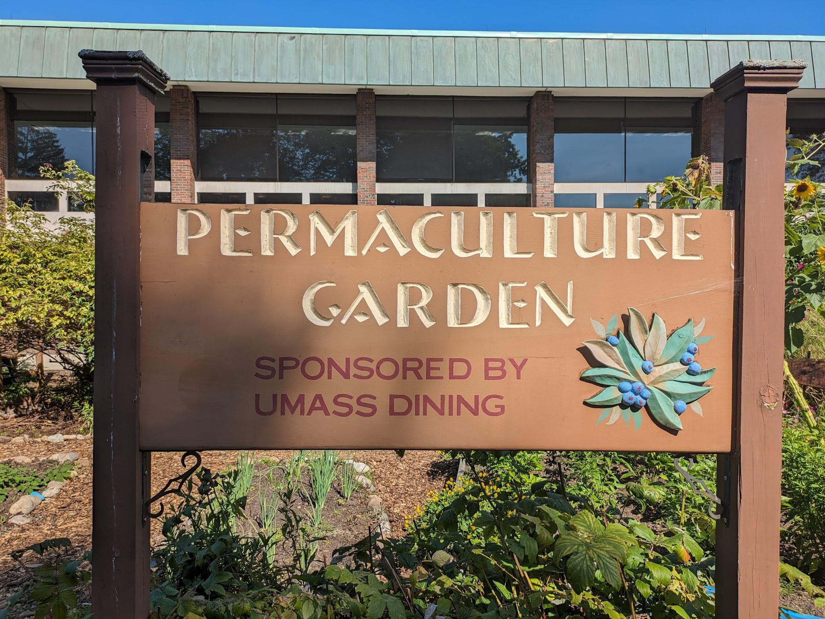
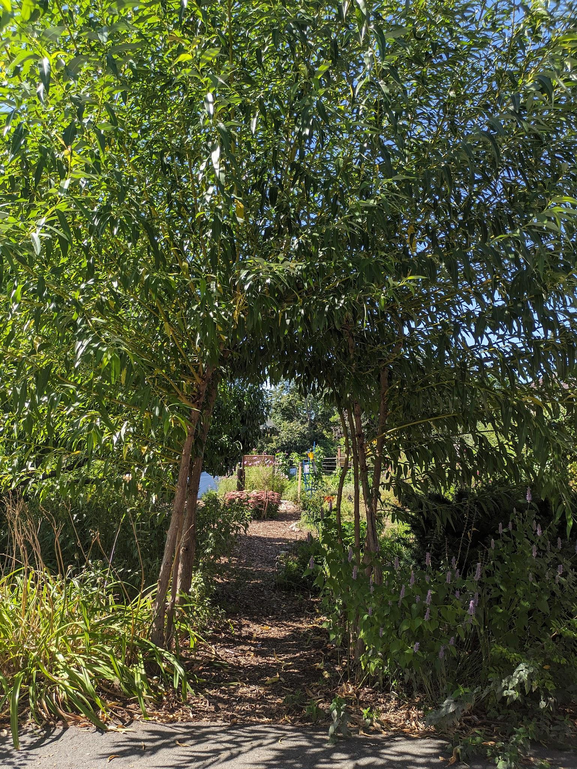
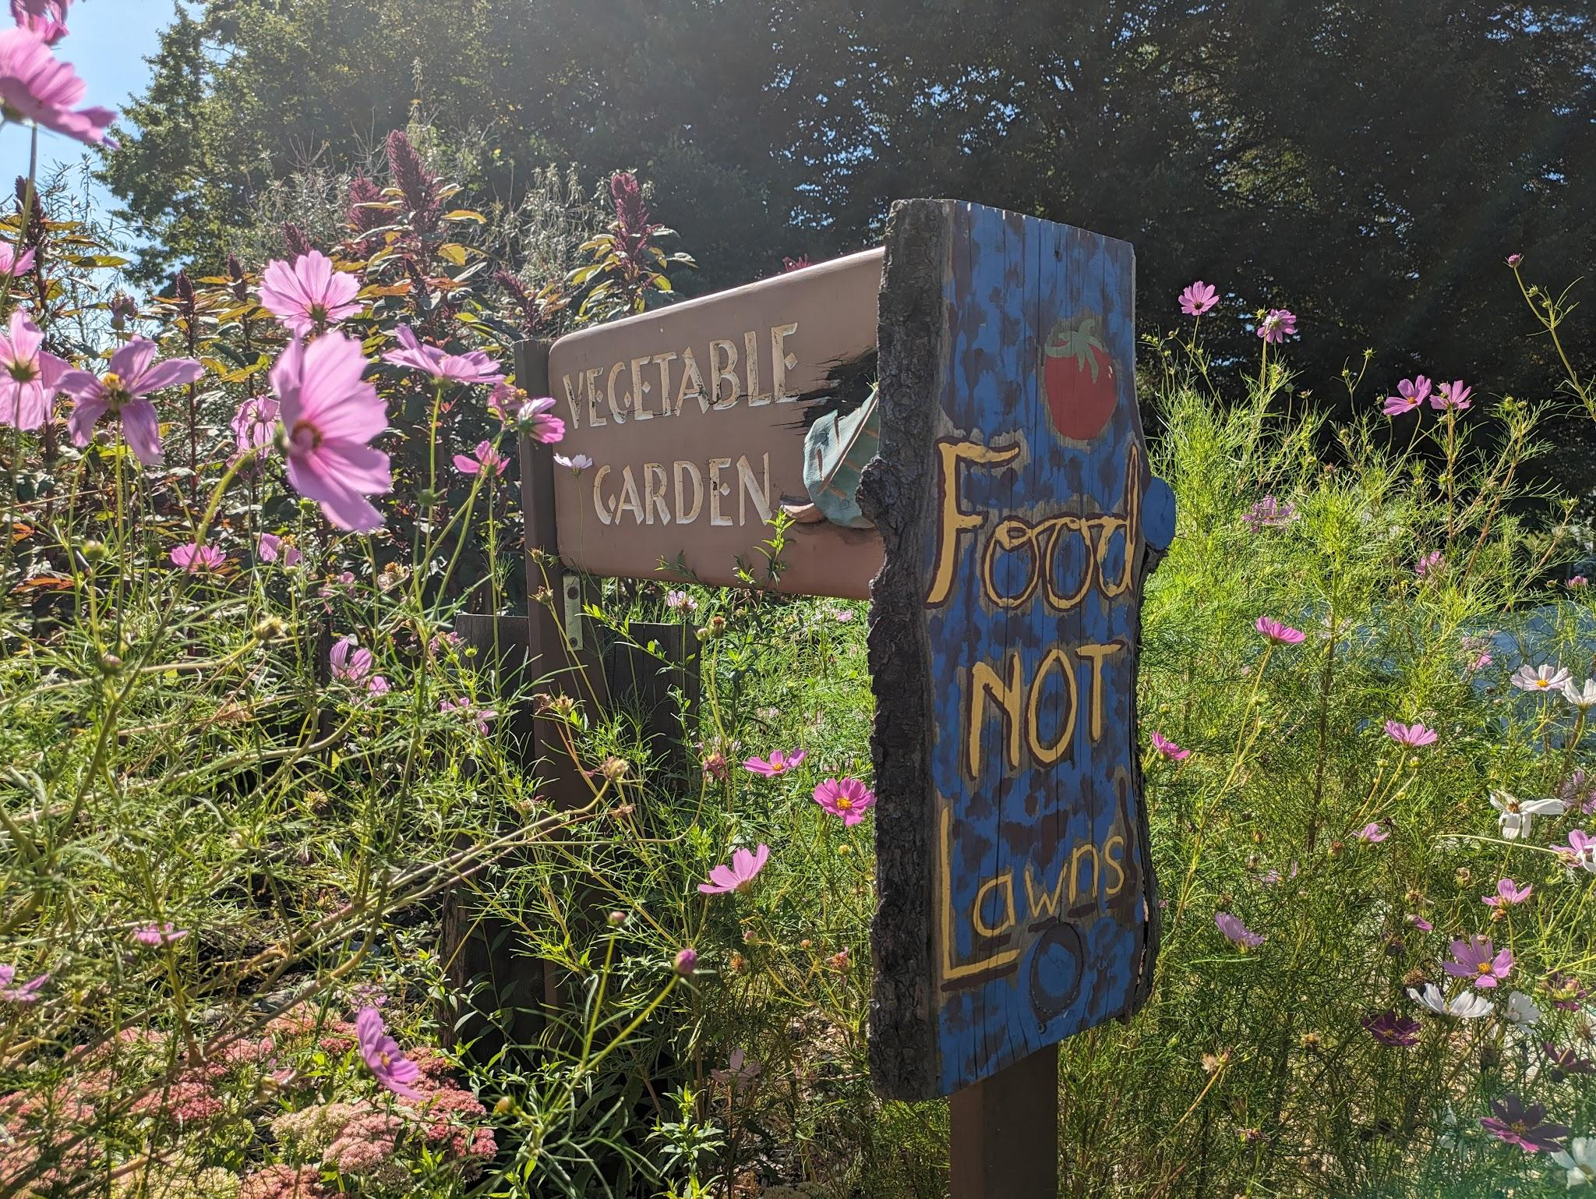

These white willows (Salix alba) are trained to grow in an arch to create a beautiful entryway into the garden.

The Franklin Permaculture Garden is sponsored and utilized by the UMass dining hall. Some of the produce from this garden ends up on students’ plates! As of 2023, the Franklin Garden is in its 12th year of production.

The woodland edge not only acts as a zone 5, but also offers a shady, cool gathering spot, as well as a seed library and a community journal/art notebook.

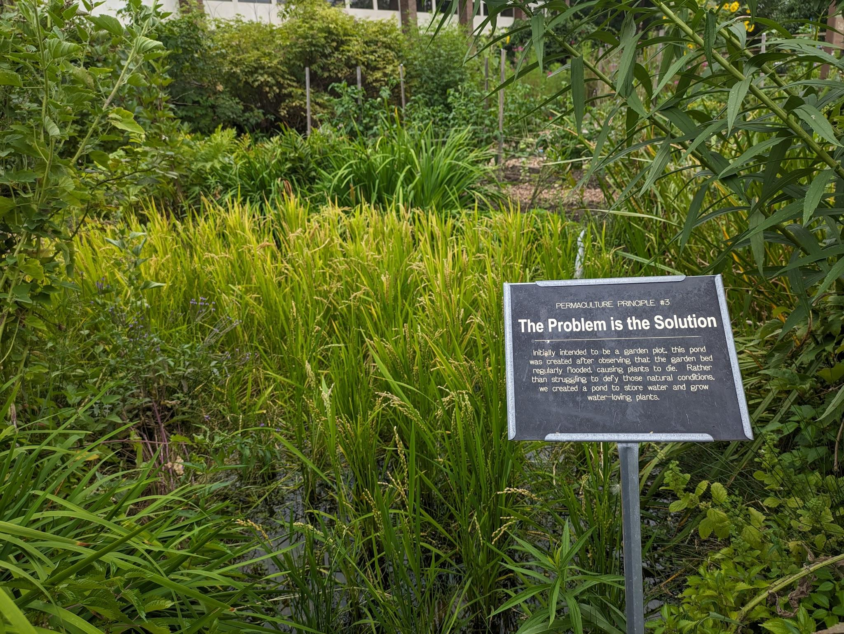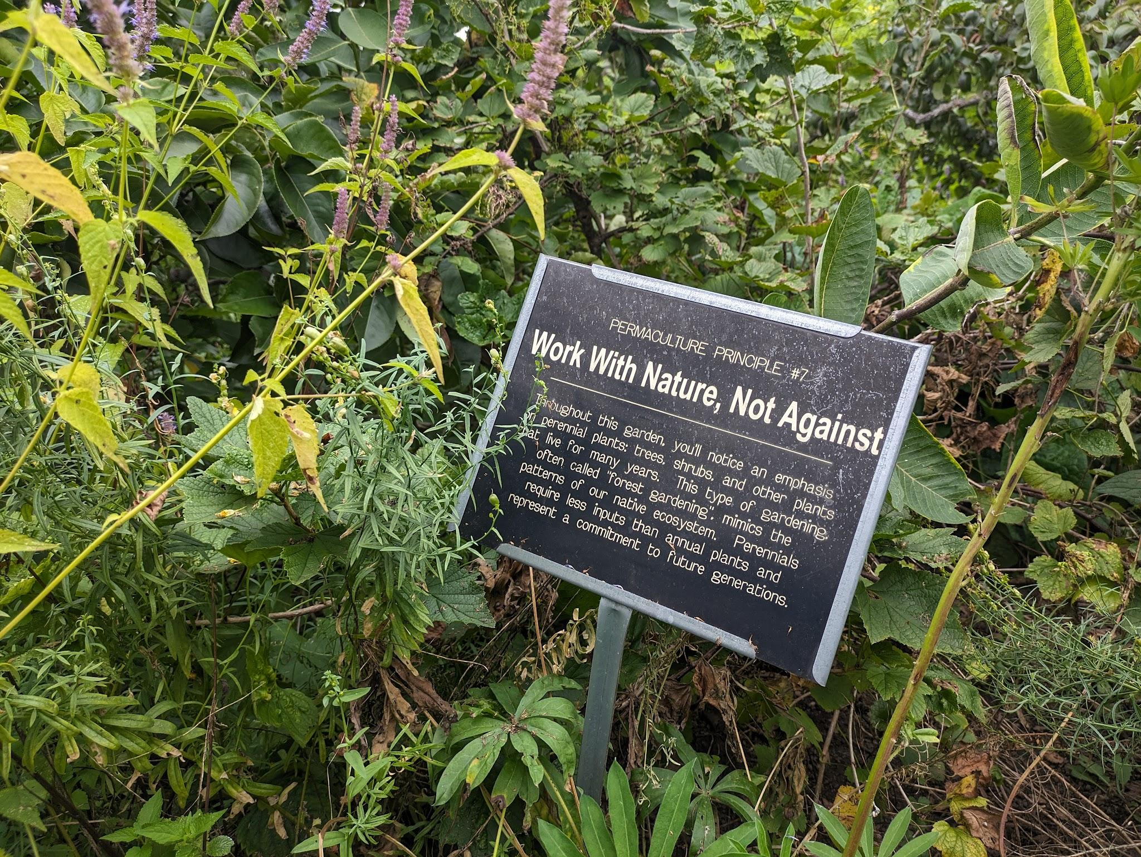

Previously a problem area in the garden, this soggy spot has been transformed into a unique pond feature!

The garden features examples of permaculture principles to inform visitors of its purpose

References:
Solkinson, D., Solkinson, G., Chi, K., Griffiths, T., Horden, A., Wilson, D. (2021). Permaculture Design Notes. Self-Published.
O’Driscoll, D. (2022 June 27). Ultimate Guide to Hugelkultur Garden Beds: Creating, Maintaining, and Benefits. The Druids Garden. https://thedruidsgarden.com/2022/06/26/ultimate-guide-to-hugelkultur-garden-beds-creating-maintaining-and-benefits/
Date: August 2023
Author(s): Meara Swinson, Elizabeth Paulson, Mateo Rull-Garza, Jaime C. Piñero

Visit our website: http://ag.umass.edu/fruit
Additional information available on the MYIPM app: https://apps.bugwood.org/apps/myipmseries/
Note: This information is for educational purposes only and is reviewed regularly for accuracy. References to commercial products or trade names are for the reader’s information. No endorsement is implied, nor is discrimination intended against similar products. For pesticide products please consult product labels for rates, application instructions and safety precautions. The label is the law. Users of these products assume all associated risks.

This work was supported in part by funding provided by USDA NIFA Extension Implementation Program, Award No. 2017-70006-27137

