Integrating research
and outreach education
from UMass Amherst

UMass Extension Fruit Team
Fact Sheet #

IPM Fact Sheet Series

American Elderberry (Sambucus canadensis): The Giving Tree

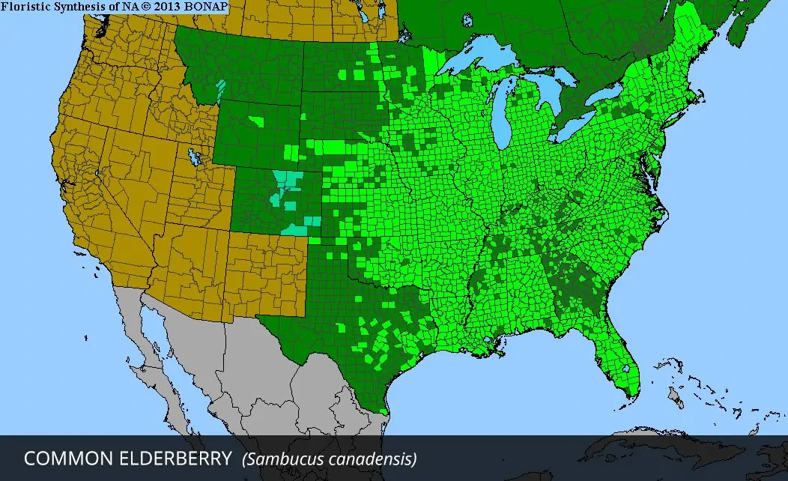
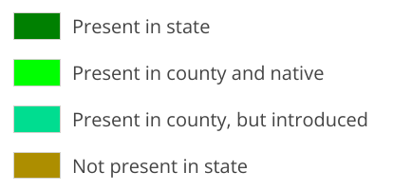
Overview: Sambucus canadensis (formerly known as S. nigra ssp. canadensis), commonly known as American Elderberry and hereafter referred to as EB, is a multi-stemmed, stoloniferous, broadleaf deciduous shrub. Its leaves are pinnately compound with five to eleven leaflets per branch; they are short stemmed, elliptic to lanceolate shaped, 5-15 cm long. Oftentimes, the lower leaflets are observed with 3 lobes. The tip tapers to a point, with sharply serrated margins (except at the tip and base). The top surface is bright green, smooth and hairless; in autumn, the leaves turn yellow-green. The branches of EB are yellowish gray, containing a soft white pith and sporting reddish purple stems that produce flowers and fruit. The fragrant, white flowers are 4.5 to 6.5 mm across, with yellow stamens, growing in cymes (clusters with a central stem) which are ~25 cm across. Berries appear as clusters of purple-black drupes, 4-5 mm across, containing up to 2000 berries. The weight of the berries causes the cymes to bend and turn downward, which can protect them from predation by birds. EB grows to a height of 1.5 to 3 meters, with a spread of 1 to 1.5 meters. It is a resilient species, a New England native hardy to USDA zones 4-9, preferring habitats such as alluvial forests, bogs, ditches, and disturbed areas such as old fields. Wet, circumneutral soil (pH 6.8-7.2) is ideal, in sun to part shade, however it is adaptable to other growing conditions, including compacted soil, salt, and urban environments.

The native range of the EB species canadensis in the US reaches from the east coast from Maine to Florida to central US, from Canada to Mexico.
Taxonomy: Formerly categorized as a subspecies of Sambucus nigra, S. canadensis is sometimes written as S. nigra ssp. (subspecies) canadensis; the name change is recognized by the Integrated Taxonomic Information System, but not accepted by all taxonomists due to morphological similarities and lack of significant evidence delineating phylogenetic (evolutionary lineage) differences. Conversely, the reasoning for distinction as a species includes incomplete reproductive barriers between S. nigra and S. canadensis as well as other species formerly categorized as subspecies. The presence of anthocyanin pigments not found in other subspecies/species, and heightened quantities of polyphenol chemical compounds also lend to the speciation of Sambucus.
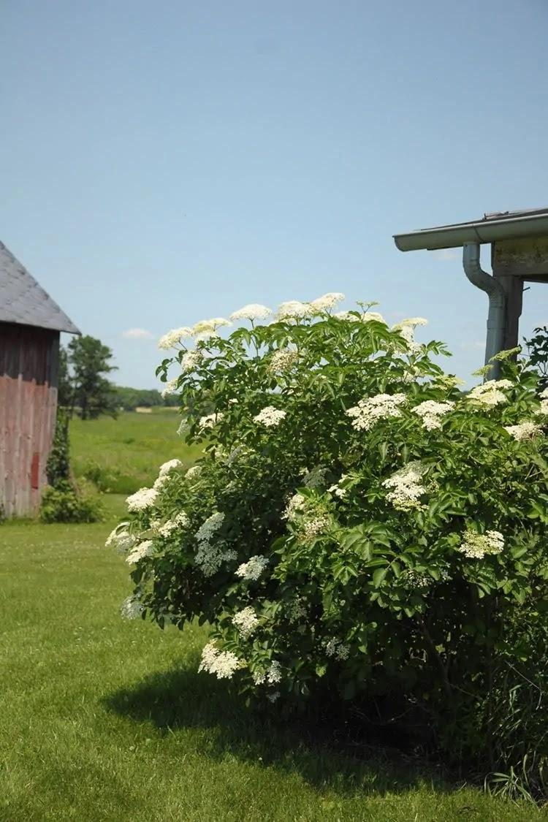
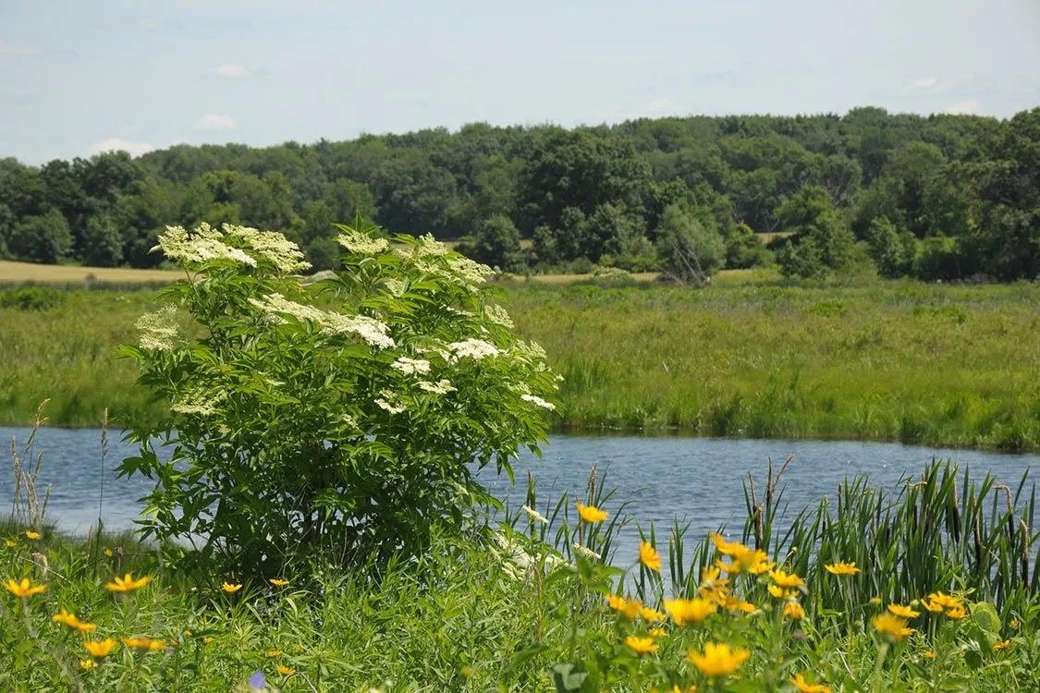
Cultivation: EB is a low-maintenance crop whose unbridled root growth ought to be considered when choosing where to establish a stand (to cultivate fruit, multiple trees must be planted). Naturalized areas, or disturbed areas one seeks to naturalize, are prime locations, and planting near a compost pile will encourage fermentation, thanks to natural EB root properties. Its profuse growth and suitability as a marginal crop makes it an excellent candidate for natural privacy screens, and its preference for wet growing conditions makes it a great addition to rain gardens, where the otherwise problematic stolonic growth provides erosion control. EB provides a habitat as well as resources for pollinators and wildlife; its fragrant flowers and flavorful berries attract pollen insect foragers and birds, and its wide, low spread provides shelter. These attractants increase biodiversity on the site, an important factor in ecological health, and this inherent alluring nature combined with its large size and rampant, unassisted growth makes EB an excellent contender for a sacrificial crop (planted with the intent of wildlife feeding on it, rather than crops the grower wants to harvest for themselves) or a trap crop (planted to attract undesirable insects so they can be addressed with pesticides or traps).

A cultivated S. canadensis tree is pictured on the left. The picture on the right is a wild specimen in its natural alluvial habitat.
https://www.prairienursery.com/common-elderberry-sambucus-canadensis.html
Ethnobotany: Multiple applications of elderberry have been observed throughout history, and its usefulness to humans extends beyond the aforementioned landscaping and ecological services. Indigenous people have been using EB as food, medicine, and more, perhaps for millenia. The plant’s nutrient profile is impressive, boasting notable amounts of flavonoids, anthocyanins, B-complex vitamins, vitamin A, and vitamin C (though vitamin C is noted in smaller amounts in wild fruits compared to cultivated fruits). The berries, first and foremost, must be cooked, sun-dried, or dehydrated in the oven (exposed to 80°C/176°F for at least 20 minutes) as they are toxic when consumed raw (as is the rest of the plant, and the seeds are always toxic). Once they are removed from the stems, cooked, and the seeds are strained from the berry pulp, they are bitter but their flavor improves when sweetened and used in syrup, wine, juice, jellies, jams, and preserves (syrup recipe included at the end of this sheet). Freezing the drupes assists in destemming. The flowers are edible as well before and after opening, and taste similar to their perfumey aroma. They can be infused in vodka for a floral spirit, or added to ice cubes and salads for an elegant touch. The medicinal qualities ascribed to elderberry comprise a fairly lengthy list; root bark tea is used to treat headaches, renal issues, and congestion, as well as inducing labor, the inner bark can be made into a poultice for wounds and soreness, and tea made from both the inner bark and root is thought to have diuretic, emetic, and laxative effects. Elderflower tea served warm is used to induce sweating; cold, it is used as a diuretic. An antiseptic wash can be concocted using the flowers and leaves, or an ointment when mixed with an oily base. Again, the entire plant is toxic to consume while fresh, so be sure to process them thoroughly. Uses other than consumption for nutritional and medicinal benefits include insect and rodent repellent made from young flowering shoots, and a decoction of the leaves can be used to treat some fungal infections including powdery mildew. Black and purple dyes can be derived from the bark and berries, respectively. Stems can be used to make flutes, whistles, and taps to drain sap from maple trees. Disclaimer: it is the responsibility of the reader to properly identify and process EB for human consumption. Some of the alleged health benefits of EB are not confirmed by the FDA.
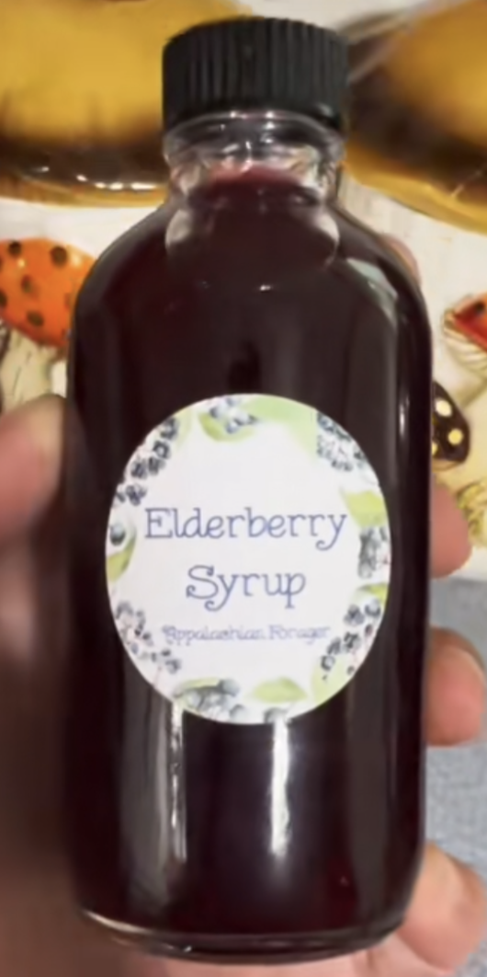

Elderberry Syrup (Ready Instantly):
Combine 1 cup elderberries (½ cup if dried), 1 cup water, 2 sticks cinnamon, 3 whole cloves, 1 tbsp fresh ginger (minced) in a pot and simmer for 25 minutes and reduce by half.
Strain liquids from solids through fine mesh strainer. Allow to cool to lukewarm, whisk in ½ cup raw local honey (syrup will be thin and runny, not thick).
Serving size: 1 tbsp. Consume in a beverage or by the spoonful.

Shelf Stable Version:
Combine 1 cup elderberries (½ cup if dried) and 1 cup raw unfiltered ACV store in cool dark place for 2 weeks.
After 2 weeks, strain liquids from solids through fine mesh strainer, set aside.
Combine 1 cup elderberries and 3 cups water in a pot with 3 cinnamon sticks and 1 whole clove, 1 tbsp chopped ginger, simmer 25 min and reduce by half.
Strain again, allow to cool to lukewarm, and whisk in 1 cup local raw honey. Combine with ACV mixture. Bottle and store, shelf stable for up to 1 year.
Serving size: 1 tsp. Consume in beverage or by the spoonful.
Recipe & photo: https://appalachianforager.com/
References: (not formatted…. should I include these in the final draft?)
https://landscapeplants.oregonstate.edu/plants/sambucus-nigra-subsp-canadensis
https://plantfinder.nativeplanttrust.org/plant/Sambucus-nigra-ssp-canadensis
https://www.wildflower.org/plants/result.php?id_plant=sanic4
https://plants.ces.ncsu.edu/plants/sambucus-canadensis/
https://www.ncbi.nlm.nih.gov/pmc/articles/PMC4859216/
https://pfaf.org/user/Plant.aspx?LatinName=Sambucus+canadensis
https://appalachianforager.com/
Date: August 2023
Author(s): Meara Swinson, Izze Clark, Mateo Rull-Garza, Jaime C. Piñero

Visit our website: http://ag.umass.edu/fruit
Additional information available on the MYIPM app: https://apps.bugwood.org/apps/myipmseries/
Note: This information is for educational purposes only and is reviewed regularly for accuracy. References to commercial products or trade names are for the reader’s information. No endorsement is implied, nor is discrimination intended against similar products. For pesticide products please consult product labels for rates, application instructions and safety precautions. The label is the law. Users of these products assume all associated risks.

This work was supported in part by funding provided by USDA NIFA Extension Implementation Program, Award No. 2017-70006-27137

