Green Genes: a DNA Curriculum
Massachusetts 4-H Program

I. Introducing the Curriculum:

UMass faculty Dr. Molly Fitsgerald-Hayes, Biochemistry Professor at the University of Massachusetts; and Dr. Frieda Reichsman, and staff Kim Pond, Massachusetts 4-H Program; and Carrie Chickering-Sears, Director of Community Education in Animal Agriculture at the University of Massachusetts have joined together to create a multi-media based curriculum, Green Genes: a DNA Curriculum. Designed for the non-scientist adult working in out-of-school settings, this curriculum utilizes the experiential learning model and current research on how today’s youth learn to assist these adults in teaching science concepts that are fun, informative and thought provoking to youth. The intended audience includes youth workers, 4-H volunteers and educators, parents providing for home-school education, and science teachers working primarily with youth between the ages of 10-13.

The curriculum is comprised of seven hands-on activities, supplemental web modules/activities and power point presentations. The activities will cover what DNA is, the role of DNA in animal and veterinary science and introduce youth to career opportunities and the role of the media. The educational activities within each unit address scientific inquiry and processing skills and are based in the experiential learning model.

The first set of activities from Green Genes: a DNA Curriculum was successfully field-tested in 2003-2004 with 48 adults, 4-H volunteers and science teachers trained who, in turn, tested their knowledge and conducted the activities with 1609 children and youth in 4-H clubs, out-of-school programs and some classroom settings. Although this curriculum is intended for the non-scientist adults working in out-of-school settings, it has shown to be successful in various classroom settings as well.

The activities in each unit can be used in a variety of settings including camp programs. Youth can go home and replicate many of the experience with their friends and family. The cost and necessary materials are minimal; many of the materials are already at hand. The simple set-up, with only brief background information needed, allows the program to be run by teen leaders and adults with limited science background.

II. About the Teaching

The Green Genes: a DNA Curriculum was designed with the Experiential Learning Model in mind. Experiential learning takes place when a person is involved in an activity, looks back at it critically, determines what was useful or important to remember, and uses this information to perform another activity.

In the past few years, research in the area of experiential learning has shown that adding several key processing steps beyond simply doing the activity or experience strengthens learning. These steps include:

• having the participant(s) experience the activity – perform or do it;
• having the participant(s) share the experience by describing what happened;
• asking participant(s) to process the experience to identify common themes;
• having participant(s) generalize from the experience to form principles or guidelines
that can be used in real-life situations, e.g., life skills;
• asking participants to apply what was learned to another situation.

Providing an experience alone does not create “experiential learning.” The activity comes first. The learning comes from the thoughts and ideas created as a result of the experience. This is a “learn by doing” or experiential process.

Experiential Learning Model

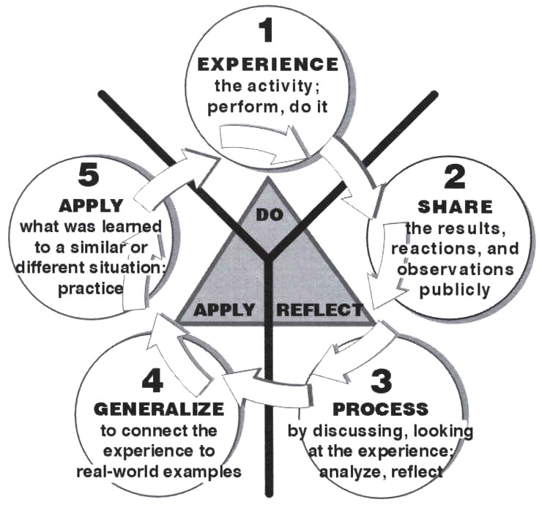
III. Why Focus on Middle School Age Group and Out-of-School Settings?

Studies have shown that during the middle school years there is a decline in youth’s interest in science, less material and fewer opportunities available, and a reduced number of youth participating in after-school programs. With an educational, fun and interactive program that is relevant to today’s society, this curriculum hopes to capture the interest of those in grades 5-8 and provide them with knowledge that will help them in school with content and science processing skills, and in life by developing the skills to decipher the DNA references and data in the media. Since all four principal investigators are women, a high priority in the curriculum development has been to make it more appealing to girls and to provide mentors and role models for those who may decide to pursue a science related field or career.

After-school programs are expected to provide academically based activities that increase learning and support area standardized test/frameworks. However, many of the staff members have limited exposure to science, in particular hands-on science or activities based on inquiry or the experiential learning method. Most experience few science classes in high school and/or at the college level; others feel uncomfortable with teaching science, or report being too busy to learn and prepare engaging science activities. This coupled with a high turnover of staff, leads to a limited amount of science being taught in non-formal educational settings.

Additionally, research shows that today’s youth learn differently as a result of being immersed in a media and digitally rich society. They, in general, have a quicker reaction period, multi-task better, are more game oriented, and are always connected to a variety of technology with instant messaging, cell phones and chat rooms. Therefore, by incorporating more technology and educational games into the curriculum activities, it is hoped that the ideas and content will be more efficiently communicated to the youth and help them become better prepared to succeed in school and in society.

IV. About This Age Group

The key to success in working with young people is planning and doing activities with the youth. With your support and guidance, they will take ownership for their own learning. Remember that each young person is unique; but growth and development tend to proceed in predictable stages. The following information on general characteristics of middle school age youth and corresponding teaching tips that may help you in your efforts:

Middle school youth enjoy planning and evaluating their own work as well as planning their own social and recreational activities. Give them opportunities for doing so.

Middle school youth like to discuss current events, international affairs and social issues. Provide them with discussion activities and games that stimulate their thinking on these matters.

Middle school youth want to make decisions but still depend on adult guidance. Work with them to set up parameters for youth and adults alike in making decisions.

Middle school youth are gaining skills in their social relationship with peers and adults. Provide activities that foster interaction with peers and adults such as tours or guest speakers.

Middle school youth experience mounting peer pressure. Use that pressure to influence positive behavior. Have groups of young people provide encouragement to individual young people.

Middle school youth can be quite self-conscious. It may be better to avoid asking youth to share their work individually in front of the group until they feel more comfortable with each other.

Middle school youth develop strong emotional attachments to older youth. Provide them with opportunities to interact with older youth and adults. (Possibly check out the local or state science fair.)

Middle school youth often make unrealistic choices. Assist them in making realistic ones by reviewing their plans, discussing alternatives, and helping them weigh options before making decisions.

V. About Life Skills:

Although researchers have identified life skills in a variety of ways, the definition used here is based on the work of Patricia Hendricks, a former Iowa State University Extension youth development specialist. She defined “a life skill as a learned ability that helps an individual be successful in living a productive and satisfying life” (Hendricks, 1996). She developed the Targeting Life Skills (TLS) model around the four Hs from the 4-H clover: Head, Heart, Hands and Health. (4-H is a youth development organization of the national, state and local cooperative extension system which uses the clover as its trademark and its motto as: I pledge my Head to clearer thinking, my Heart to greater loyalty, my Hands to larger service and my Health to better living for myself, my club, my community and the world). There are two general categories of skills for each of the four headings.
Head: managing which includes planning, goal setting, keeping records, using resource wisely and thinking which includes a willingness and readiness for learning, decision making and critical thinking skills, and problem solving capabilities.

Heart: relating which includes communication, teamwork, cooperation, accepting differences and conflict resolution skills and caring, that of showing concern and empathy for others and sharing.

Hands: giving which includes citizenship, leadership and helping others through community service learning opportunities and working which relates to being productive, sharing your talents with others and teamwork.

Health: living which includes self-esteem, taking responsibility, dealing with emotions, and developing character and being which includes managing stress, maintaining healthy lifestyle choices, and personal safety.

Hendricks (1997) further suggests that youth programming must provide developmentally appropriate opportunities for young people to experience life skills, practice them until they are learned and be able to use them as necessary throughout life. Each unit of this curriculum will identify the life skills being thought and experienced. Some areas to be taught include communication, learning to learn, decision making, teamwork, keeping records, critical thinking, and cooperation skills. Add diagram of TLS at end of unit.
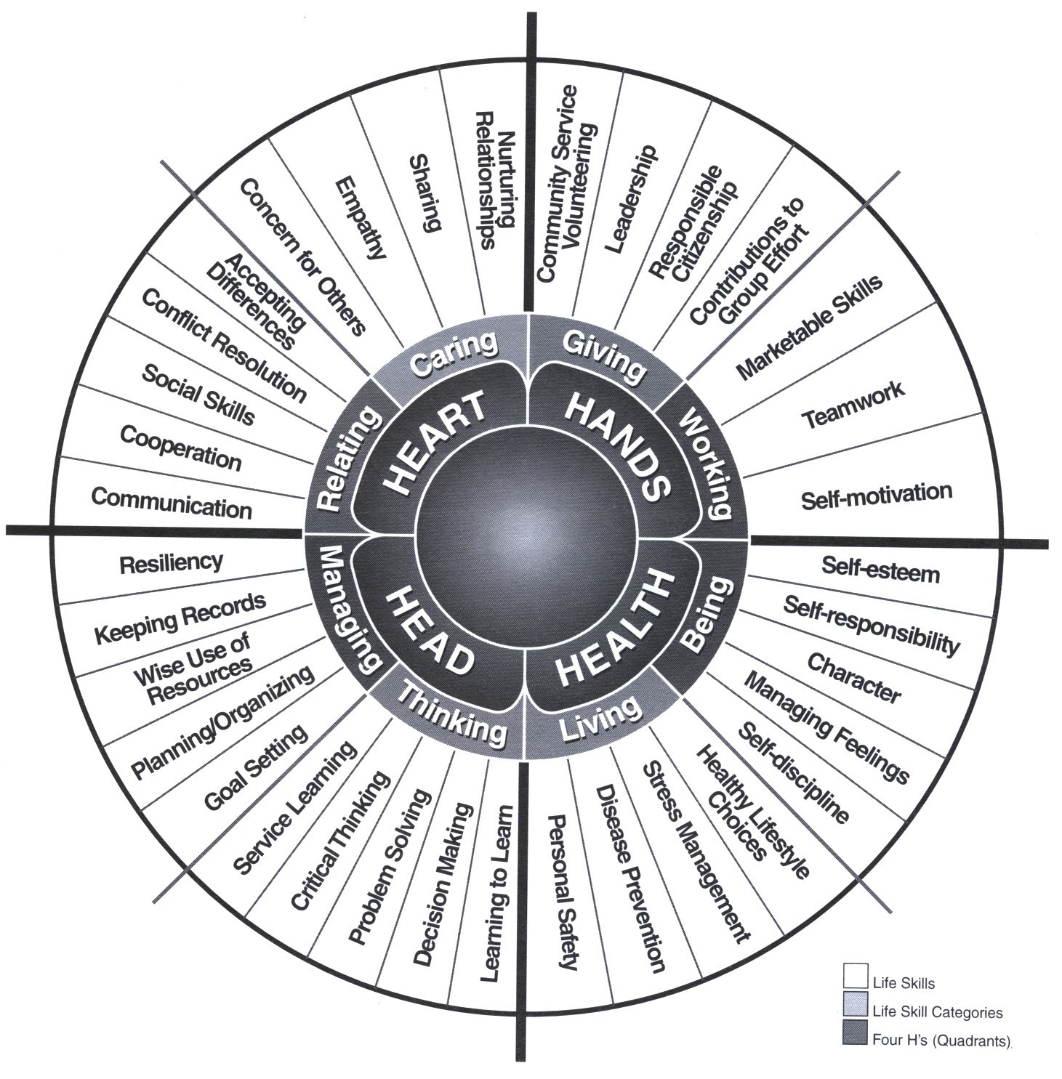

VI. Fit with the Massachusetts Science and Technology/Engineering Curriculum Frameworks:

The Massachusetts Science and Technology/Engineering Curriculum Frameworks (May 2001) is one of seven curriculum frameworks that advance Massachusetts's educational reform in learning, teaching, and assessment and revised from the 1995 frameworks. There are four content strands (Earth and Space Science, Life Science, Physical Sciences, and Technology/Engineering). "Inquiry" is part of each strand.

The revised framework derives from two reform initiatives in Massachusetts: the Education Reform Act of 1993 and Partnerships Advancing the Learning of Mathematics and Science (PALMS). The revision panel referred to the Benchmarks for Science Literacy - Project 2061, the National Research Council's National Science Education Standards and the Technology for All Americans Project among other studies/documents.

The Massachusetts Science and Technology/Engineering Curriculum Frameworks are available on-line at www.doe.mass.edu/frameworks/current.html.

This curriculum meets the Massachusetts Science and Technology/Engineering Curriculum Frameworks within Strand 2: Life Science (Biology) area in the following ways:
Content for Grades preK-2 will be reinforced. Addresses heredity, Topic Heredity #4 -describe ways in which many plants and animals closely resemble their parents in observed appearance.

Content for Grades 3-5 will be reinforced. Addresses adaptations of living things, Topic: Adaptation of Living Things #6: give examples of how inherited characteristics may change over time as adaptations to changes in the environment that enable organisms to survive, e.g., shape of beak or feet, placement of eyes on head, length of neck, shape of teeth, color.

Content for Grades 6-8 will be taught. Addresses reproduction and heredity, Topic: Reproduction and Heredity- #7: recognize that every organism requires a set of instructions that specifies its traits. These instructions are stored in the organism’s chromosomes. Heredity is the passage of these instructions from one generation to another; and #8: recognize that hereditary information is contained in genes located in the chromosomes of each cell. A human cell contains about 30,000 different genes on 23 different chromosomes. Also addresses Evolution and biodiversity as related to agriculture. Topic: Evolution and Biodiversity - #10 -Give examples of ways in which genetic variation and environment factors are causes of evolution and the diversity of organisms.

The curriculum will also set the path and basic learning blocks for several of the frameworks listed in the high school one year Life Science program.

_____
Experiential Learning Model and Targeting Life Skills courtesy of UVM

